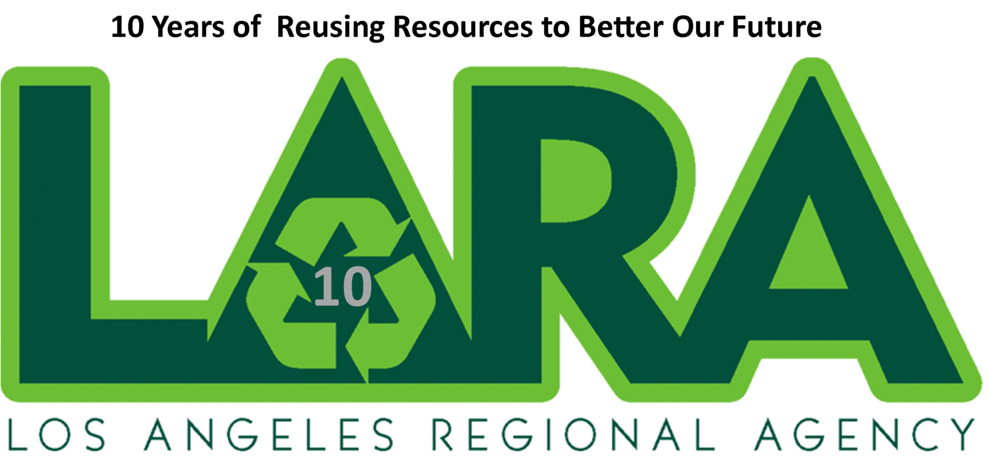

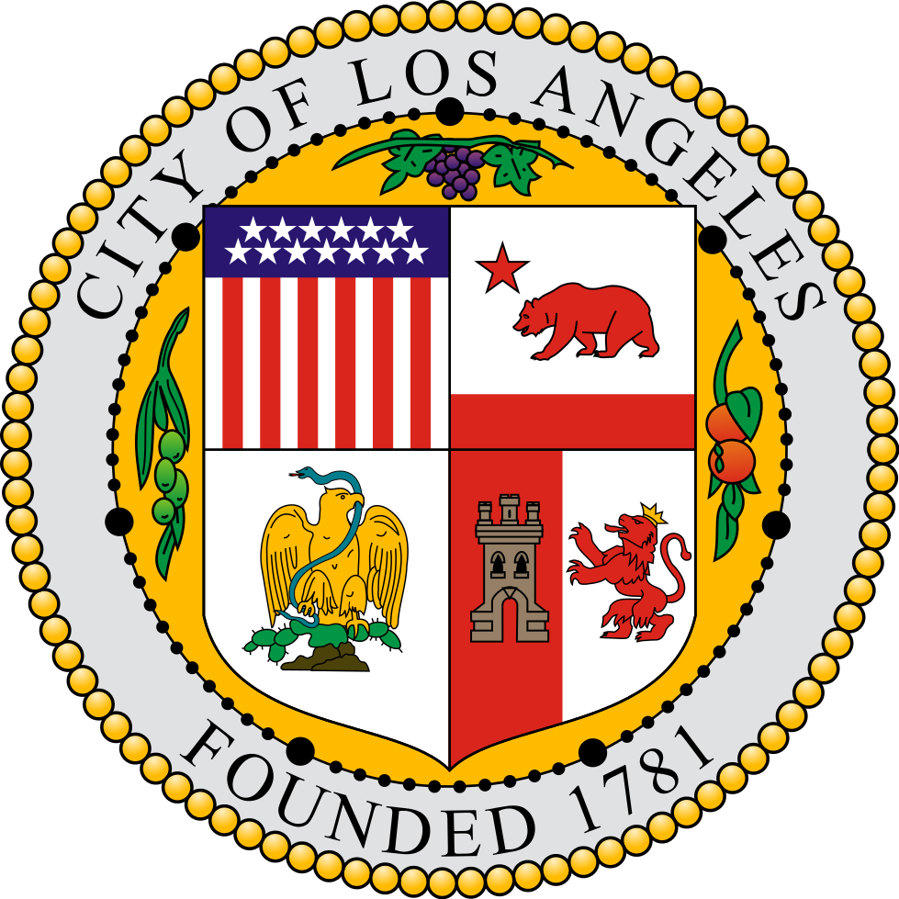

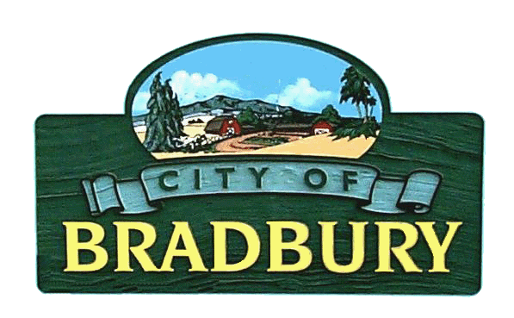

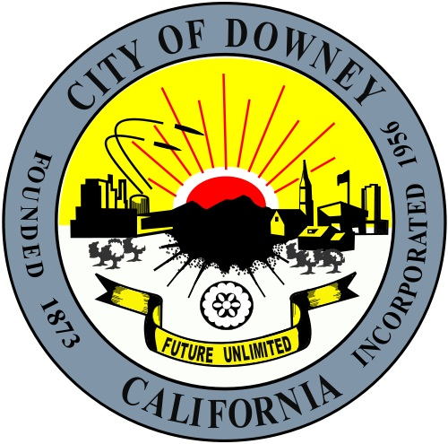

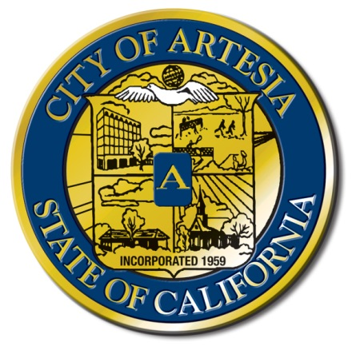



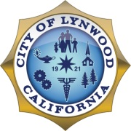

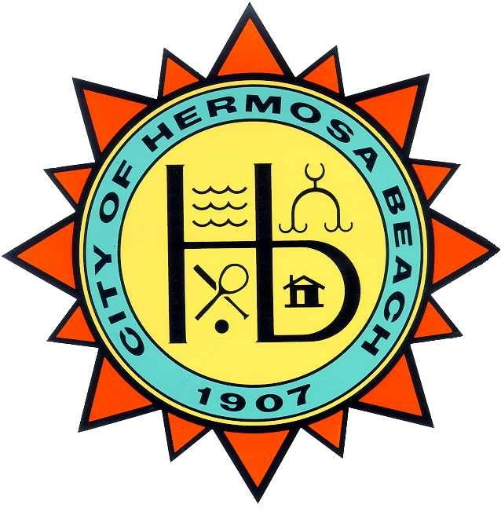

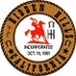

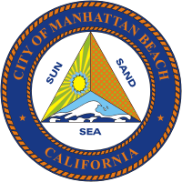

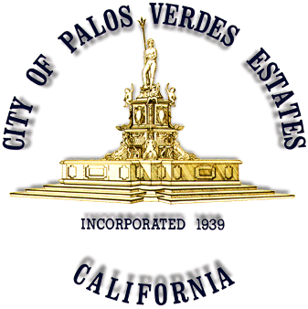

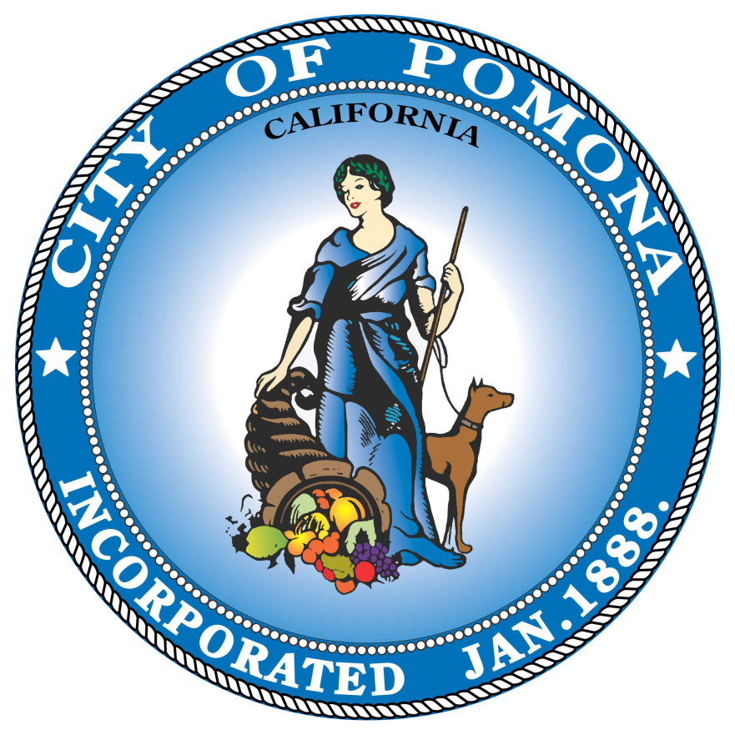



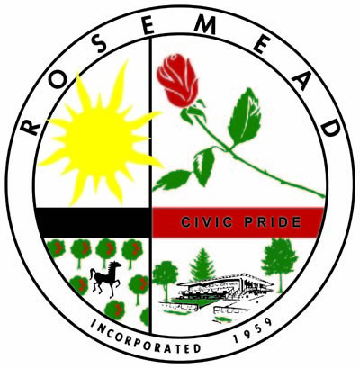

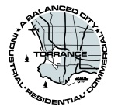

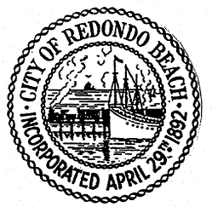



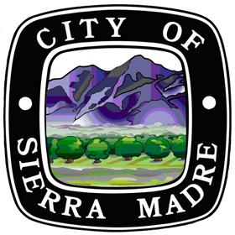

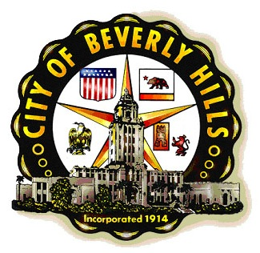

**HAPPY 10-YEAR ANNIVERSARY**

**2004 LOS ANGELES INTEGRATED SOLID WASTE MANAGEMENT AUTHORITY 2015**

**The LARA 2015-16 Executive Board**

Chair – Karen Herrera, Deputy City Manager, City of Duarte

Vice Chair – Lorry Hempe, Public Works Special Projects Manager

Treasurer – Lauren Ramezani, Senior Administrative Analyst, City of Rancho Palos Verdes

Secretary – Alison Sherman, Waste Management Coordinator, City of Torrance

Executive Director – Karen Coca, Division Manager, City of Los Angeles

Administrator – Nady Maechling, Engineer Associate II, City of Los Angeles

**AGENDA**

Thursday, June 18, 2015, 10:00 a.m. to 12:00 p.m.

Barbara J. Riley Community Center, 7810 Quill Ave. Downey, 90242

1. Call to Order – Chair Karen Herrera
2. Pledge of Allegiance – Andrew Perry, City of Artesia
3. Roll Call and Declaration of Quorum – Secretary Alison Sherman
4. Public Comments and Announcements – All (5 min; Timekeeper – Julie Jacobe)
5. Opening Remarks, Introductions – Karen Herrera, All (5 min)
6. Approval of 1st Quarter Minutes – 4/23/2015 (5 min)
7. Executive Director Report – Executive Director Karen Coca (10 min)
8. 2015-16 Budget Presentation – Treasurer Lauren Ramezani (20 min)
9. Re-Refined Oil, A Summary of the 5/14 Workshop – Jennifer Pinkerton, City of Los Angeles (30 min)
10. CalRecycle Report – Mia Hunt, CalRecycle (10 min)
11. Next Meetings:

* Thursday, 9/17/2015 (611 E. Sierra Madre Blvd., Sierra Madre, 91024)
* Thursday, 12/3/2015 (30940 Hawthorne Blvd. Rancho Palos Verdes, 90275)
* Thursday, 3/17/2016 (TBD)

1. Adjournment

NOTES:

* Agenda items may be taken out of order
* To request special accommodations for persons with disabilities, verify if an item will be heard, or request copies of the agenda items, please contact [sanab939@lacity.org](mailto:julie.ann.jacobe@lacity.org).
* Light refreshments will be served by the host City of Downey